STANDARD OPERATING PROCEDURE - REXGEN

SOFTWARE INSTALLATION

Before proceeding with the installation, please ensure that you have acquired administrative privileges. Make sure you have installed the Microsoft Visual C++ Redistributable (x86).
You can download it from the following link: https://www.microsoft.com/en- in/download/details.aspx?id=48145

The latest release of ReXdesk software can be directly downloaded from the Influx technology website's support page.
To begin the installation of the ReXdesk software, open the installer by running the set-up file

DRIVER INSTALLATION

To install the ReXgen driver, run the .exe file in this location:
C:\Program Files (x86) \Influx Technology\ReXdesk\Drivers.

The .exe file can also be found under Influx technology's start menu. Run the ReXgenInstaller.exe file.

SOFTWARE UPDATE
Uninstall any previous version of ReXdesk before installing the new version.
Updated releases of ReXdesk software can be directly downloaded from the Influx technology website Link: https://www.influxtechnology.com/rexdesk
To begin the installation of the ReXdesk software, open the installer by running the set-up file

FIRMWARE UPDATE

The firmware file is located in (C:\Program Files (x86) \Influx Technology\ReXdesk\Firmware)
The "Reflash" option in the device menu allows the user to update the firmware on the data logger.

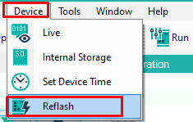
- Do not disconnect the logger until the logger LED stops flashing.
- The logger will automatically reconnect to the software after re-flashing.
- Please ensure that the internal storage is formatted after re-flashing the logger
- Update ReXgen with new configuration once updates are done.
Note:

- Do not roll back from current version of firmware to older version of firmware, data recorded will be lost.

CONFIGURING STEPS TO LOG CAN TRACE DATA IN REXGEN AND EXTRACT IT TO BLF /ASC FORMATS
Drag and drop "log all "from tools to the required CAN bus (CAN0/1/2/3) or LIN Bus:

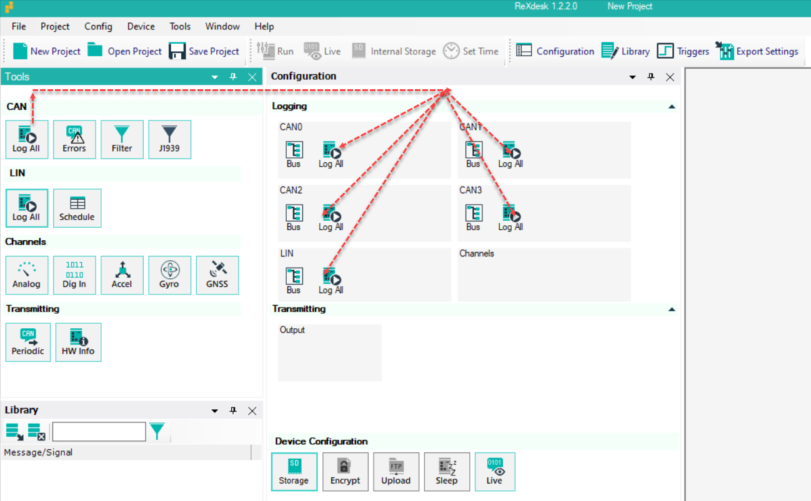

To set CAN speed, click on the Bus icon

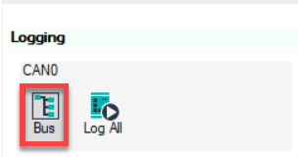

Specify the required information in the following window.

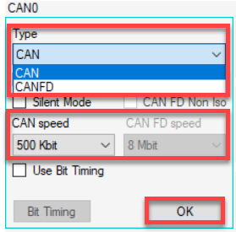

Set the max log size/time for log files
Click on "Storage" and choose max log time & size

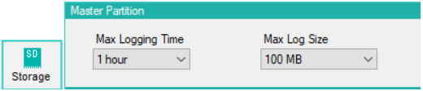

Interface reXgen and click "Run" to update the configuration

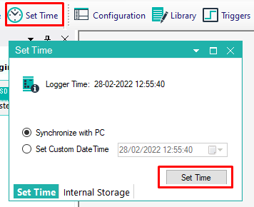
Check the LED indications on rexgen – LED lights will be bold for the configured CAN bus
Once rexgen is interfaced to CAN, LED lights start blinking, indicating that it started logging
Also, verify that a new log file is created for updated internal storage configuration with proper start and end times. Else, update the time by using the "set time" option

After logging, select the logged file from "Internal storage" and click "Download."

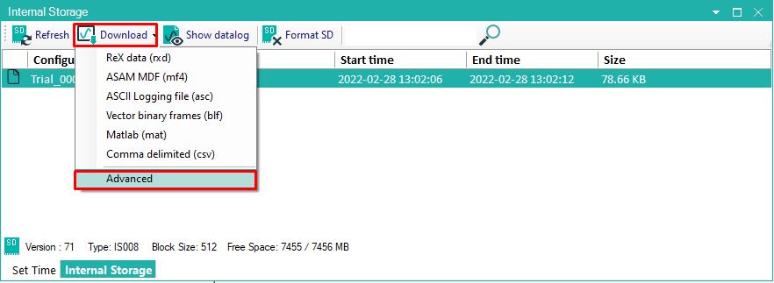

Click the "Advanced "option

Select "output format" and "output location", and click process.

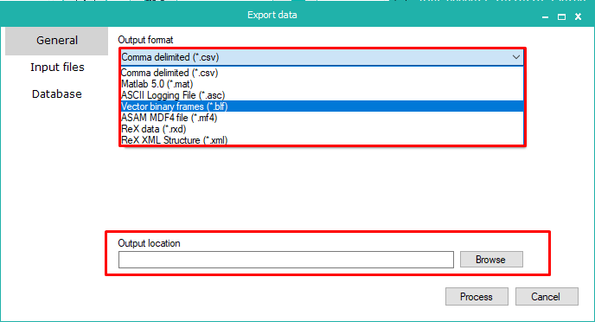
Note:

- Please refer ReXgen user manual for further Assistance

ReXgen Manual can be accessed from the "Help" menu in ReXdesk

